Create Your First Photo Story

_________________________________________

Use Photo Story 3 for Windows to create visually compelling and fun stories using your pictures and music. This article walks you through the basics of creating a photo story and shows you how easy and fun it can be!

_________________________________________

Step 1: Downloading and Opening Photo Story

To download Photo Story
1. Go to http://www.microsoft.com/windowsxp/using/digitalphotography/photostory/default.mspx
2. Click Download Photo Story and then follow the directions as given.

To open Photo Story
1. Click Start, point to All Programs, and then click Photo Story 3 for Windows.
2. On the Welcome page, click Begin a new story, and then click Next.

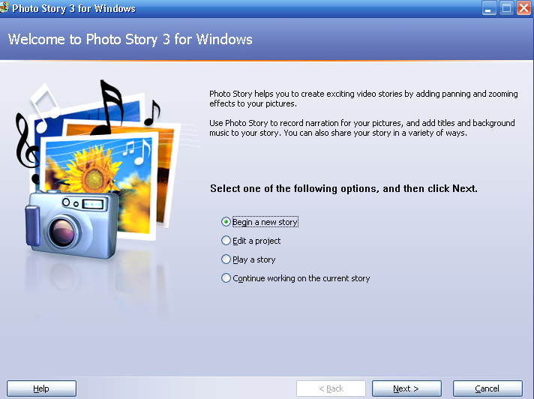

_________________________________________
Step 2: Importing and arranging your pictures
First, add the pictures that you want to use in the story, and then arrange them in the order that they will be viewed.

To add pictures to your photo story
1. On the Import and arrange your pictures page, click Import Pictures.
2. In the File Browser dialog box, browse to My Documents\My Pictures\Sample Pictures.
3. Add all of the pictures listed. To add more than one picture at a time, press and hold the CTRL key and click on the pictures you want to add, and then click OK. All of your pictures should now be present in the filmstrip, as shown in the following screen shot.
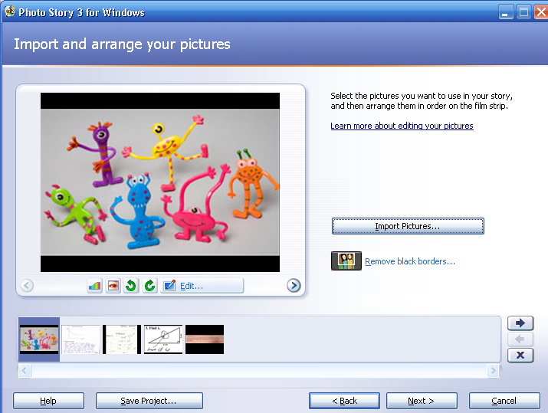
The filmstrip in Photo Story is a great place to quickly make changes to your pictures and story. For example, you can drag a picture in the filmstrip to change the sequence. You can click a picture in the filmstrip and click Edit to change the appearance of the picture by rotating it, adjusting the color, fixing red eye or adding effects. Try adding an effect to one of the pictures to see what they look like.

4. When you are finished making changes to your pictures, click Next to continue.
_______________________________________

Step 3: Adding a title to your pictures
With Photo Story 3 you can add text to a picture to create a title for your story.

To add text to your pictures
1. On the Add a title to your pictures page, click the first picture, and then type My first photo story in the text box to the right of the picture.

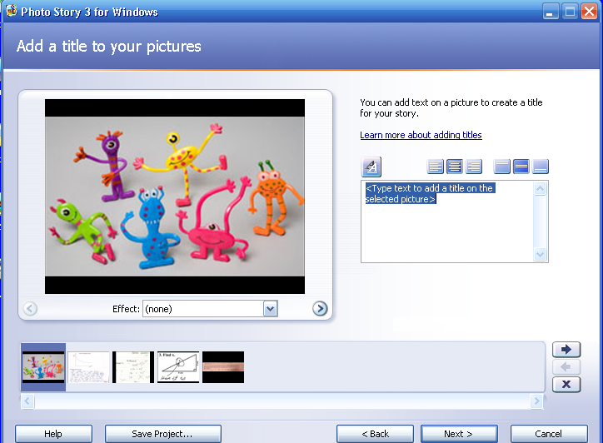

2. Click the Select Font button.
3. In the Font dialog box, under Font style, click Bold, and then click OK.
4. Click the Align Top button to move the title up on the page. Repeat steps 1 and 2 to add text to another picture, and experiment with different text styles, sizes, and alignments, using different formatting buttons.
5. When you are finished adding text to your pictures, click Next.

_____________________________________________

Step 4: Narrating your pictures
You can add narration and custom pan and zoom effects to your photo story to make it more unique and personal. There is also a text input area to create cue cards which can be a helpful memory aid when narrating your pictures.

To add narration to your story
1. On the Narrate your pictures and customize motion page, click the Microphone button.
This will launch the Sound Hardware Test Wizard. Complete the wizard by following the onscreen instructions and get ready to record narration.
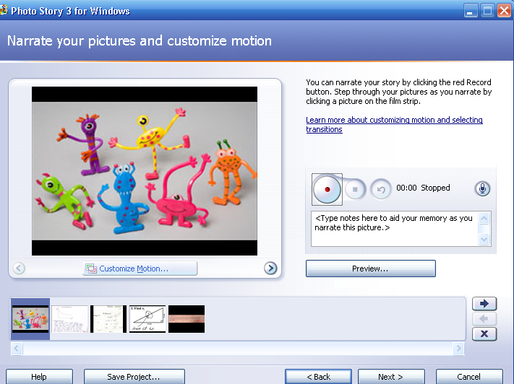
2. Click a picture in the filmstrip.
3. Add any desired text in the cue card area.
4. Click the Record Narration  button to start recording narration. The red dot in the record button will flash indicating recording is taking place.
5. When you have finished, click the Stop Recording  button.
6. Repeat steps 2 thru 4 for each picture for which you want to add narration.
7. Once you have added narration, click the first picture in the filmstrip, and then click Preview to see how your story looks and sounds.
8. Close the preview window, and click Next to continue to the next step.

_________________________________________
Step 5: Adding background music (optional)
With Photo Story 3 you can add music to your story by using Windows Media Audio (WMA), MP3, or WAV files or by using the Create Music option to create custom music that suites your story and taste.

To add pre-recorded music to your story
1. On the Add background music page, click the first picture in the filmstrip and then click Select Music.
2. On the File Open dialog box, click My Documents from the left menu.
3. Browse to My Music\Sample Music, click Beethoven's Symphony No9 (Scherzo).wma, and then click Open.
The music you just added is shown as a colored bar above the picture in the filmstrip, as shown in the following screen shot. This helps you determine which pictures will be shown for each piece of music you add. This is particularly helpful when you add more than one song to your story.

To create music for your story

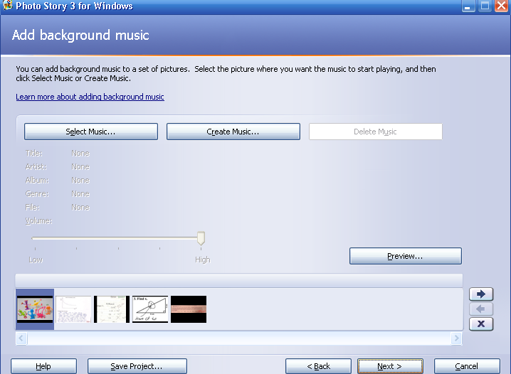

1. Click the third picture in the film strip, and then click Create Music.
2. In the Create Music dialog box, in the Genre drop-down list, scroll down and select Soundtrack.
3. In the Style drop-down list, select Soundtrack: Mysterious Cave.
4. You can leave the default Bands and Moods, or choose different ones.
5. Click Play to hear what the music will sound like.
6. When the music has finished playing, click OK to close the Create Music dialog box.
There are now two different pieces of music shown as colored bars above the pictures in the filmstrip.
7. Click the first picture in the filmstrip, and click Preview, to see how well your music fits the story.
You may need to adjust the music volume levels to accommodate your narration. To do this, simply click the picture in the filmstrip and then adjust the music volume using the volume slider bar. You may need to adjust the volume and preview your story a few times to get it just right.
8. Click Next, to move on to the final steps.

_________________________________________

Step 6: Saving your story
When you save your photo story, all the pictures, narrations, and music are compiled into a video file that you can view in Windows Media Player.

To save your photo story for playback on your computer
1. On the Save your story page, verify that Save your story for playback on your computer is selected in the activities list.
2. Click Browse to specify the location and file name of your story.
3. On the Save As dialog box, browse to My Documents\Desktop.
4. In the Filename text box, type My First Story.wmv.
5. Click Save, and then click Next.

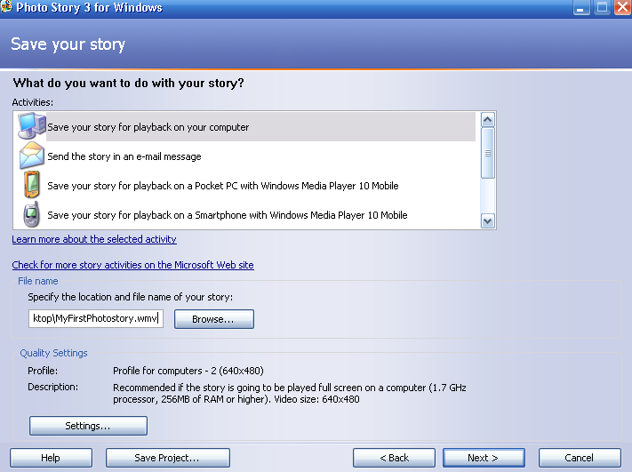

To save your photo story on your portable USB drive
1. Open your portable USB drive folder.
2. On the desktop, find My First Story.wmv.
3. Drag the My First Story.wmv file into your USB drive folder.

_________________________________________

Step 7: Viewing your story
Now you can share your movie with the world! Your movie has a .wmv file extension, indicating to the computer that it should open the file with Windows Media Player.

To view your story as you finish
1. When your story is built and saved, the Completing Photo Story 3 for Windows page will appear. You can view your newly created story or begin a new story from here.
2. To see what you have created, click View your story. Windows Media Player will open and your story will begin to play!

To view your story later
1. Open your portable USB drive folder.
2. Click on My First Story.wmv (you saved the story here in Step 6).
3. Windows Media Player will open and your story will begin to play!

_________________________________________

